[Managing Advanced Release Orchestration Scenarios with XL Release](https://blog.xebialabs.com/2016/06/28/managing-advanced-release-orchestration-scenarios-xl-release/" \o "Permanent Link to Managing Advanced Release Orchestration Scenarios with XL Release)

# Use a Master Release to Manage Sub-releases

* Automatically orchestrate dozens of related releases
* Manage dependencies between releases
* Group related releases
* Reuse existing release processes

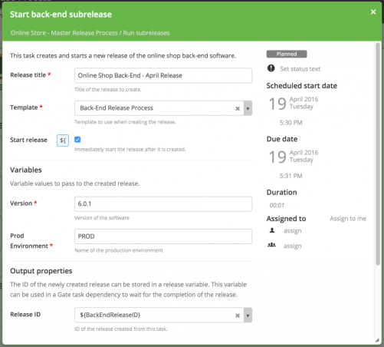

[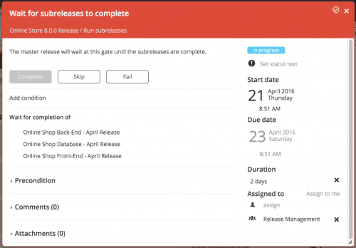](https://i2.wp.com/blog.xebialabs.com/wp-content/uploads/2016/05/gate_task_with_dependencies_cropped.png)

For example, these two phases are part of a master release that will start nine release processes for related microservices and components:

[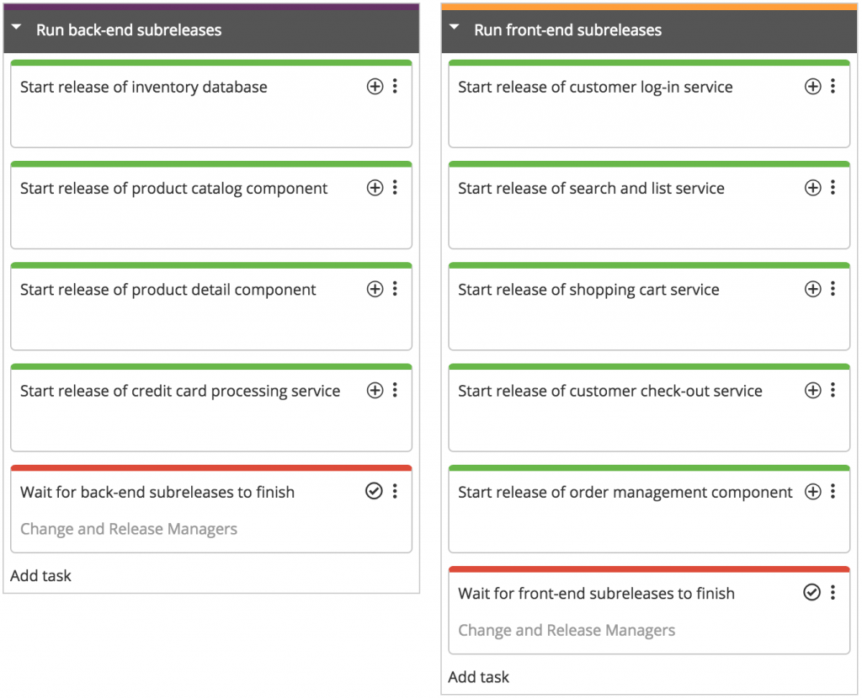](https://i0.wp.com/blog.xebialabs.com/wp-content/uploads/2016/06/01-subreleases.png)

In XL Release, the master release depends on these “subreleases”, meaning that it will wait for them to complete before it continues. This structure ensures that the overall release process will only be complete when all components and services have been released successfully.

You can see how the subreleases fit into the overall release timeline on the master release’s dashboard:

[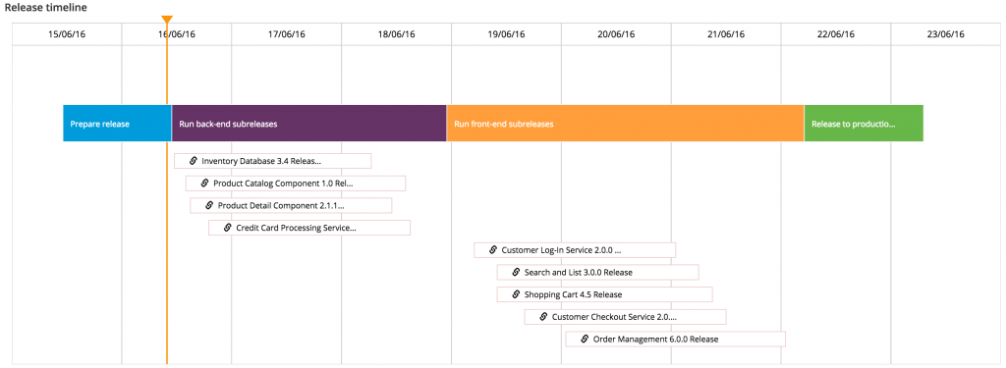](https://i1.wp.com/blog.xebialabs.com/wp-content/uploads/2016/06/02-timeline.png)

# Kickstart a Set of Releases

But you aren’t limited to the master release/subrelease model. XL Release is flexible, so you can set up your pipelines to reflect real-world release processes and update them as they change and improve.

For example, you might want to create a single release that serves to “kickstart” other releases, but doesn’t monitor their status or depend on their completion. This lets you centralize the way you start a set of releases; you only have to trigger the kickstart release either automatically or manually, and it will take care of the rest.

[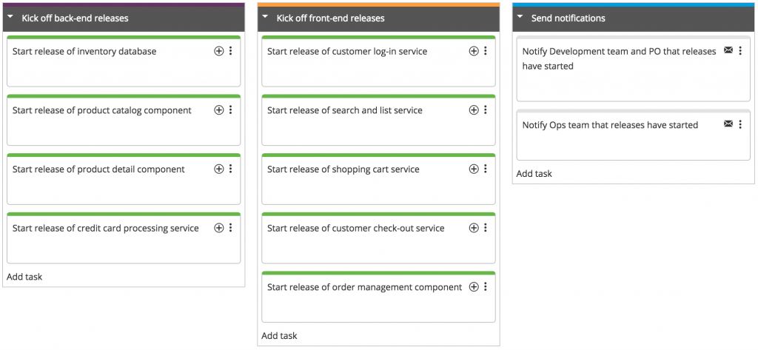](https://i0.wp.com/blog.xebialabs.com/wp-content/uploads/2016/06/03-kickstart-release.png)

# Chain Releases Sequentially

Or maybe you’d rather build a “chain” of releases that run in sequence, so that just before each release completes, it starts the next one in the chain. This structure allows you to enforce the order in which the releases execute and ensure that each release in the series doesn’t start until its prerequisite releases complete successfully.

[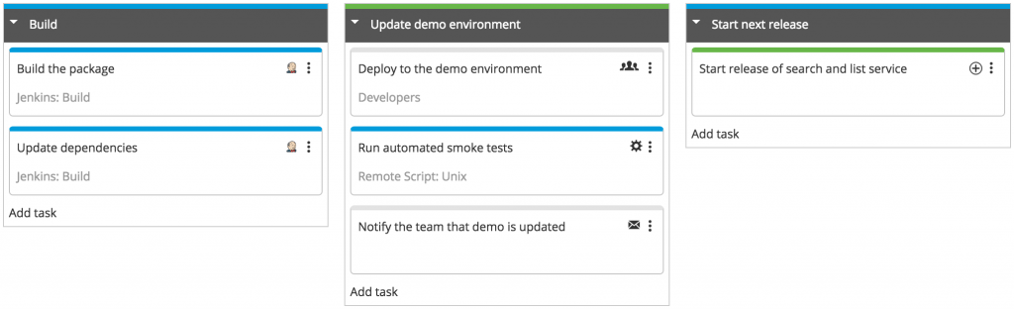](https://i2.wp.com/blog.xebialabs.com/wp-content/uploads/2016/06/04-release-chain-new.png)

# Model Development Sprints and Other Business Processes

You can even use XL Release to model and orchestrate recurring processes such as development sprints and releases with marketing tasks. XL Release collects data about the process—such as the time spent on each task and how the task workload is allocated—which can help you identify bottlenecks and spot potential areas for automation.

[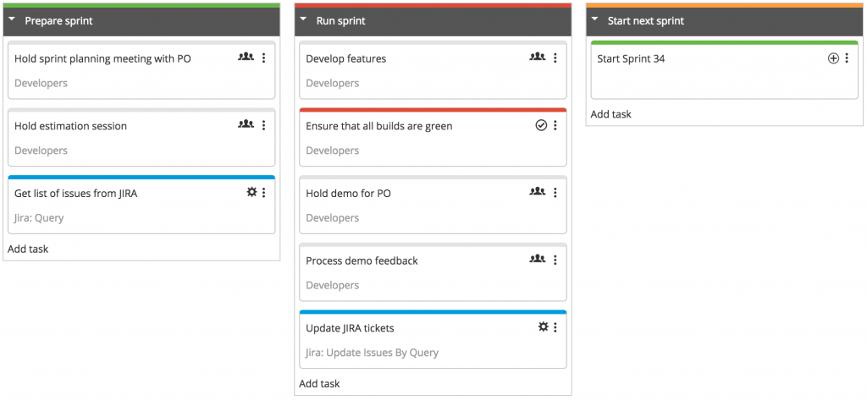](https://i0.wp.com/blog.xebialabs.com/wp-content/uploads/2016/06/05-sprints.png)